Englewood Truck Stop, Inc. &
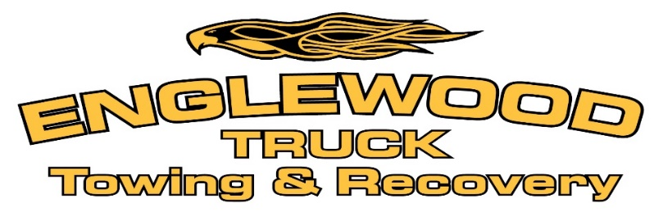
Englewood Towing and Recovery, Inc.
DBA Englewood Truck Towing and Recovery

credit application – business account

Please fill out the information below and email to ar@englewoodtruck.com, or fax this form to Attn: Accounts Receivable at (937) 832-2486.

Business Contact Information

Company Name:

Title:
Phone: |  |  | Fax:

E-mail
Registered Company Street Address:
City: |  |  | State: |  |  | Zip Code:

Date Business Commenced:
Sole proprietorship Partnership C-Corporation S-Corporation LLC
Other:

Business & Credit Information
Primary Business Address:
City: |  |  |  |  |  |  |  |  | State: |  |  |  |  | Zip Code:
How long at current address?
Phone: |  |  |  |  |  |  |  | Fax: |  |  |  |  | Email:
Bank Name:
Bank Address:
City: |  |  |  |  |  |  |  |  | State: |  |  |  |  | Zip Code:
Bank Phone: |  |  |  |  |  |  |  |  | Fax: |  |  |  |  | Email:
Account #: |  |  |  |  |  |  |  | Account Type: |  |  |  | Savings Checking |  |  |  | Other:

Business Trade References
Company Name:
City: |  |  |  |  |  | State: |  |  |  | Zip Code:
Phone: |  |  |  |  | Fax: |  |  |  | Email:
Account Type: |  |  | Customer Vendor Other:
Company Name:
City: |  |  |  |  |  | State: |  |  |  | Zip Code:
Phone: |  |  |  |  | Fax: |  |  |  | Email:
Account Type: |  |  | Customer Vendor Other:
Company Name:
City: |  |  |  |  |  | State: |  |  |  | Zip Code:
Phone: |  |  |  |  | Fax: |  |  |  | Email:
Account Type: |  |  | Customer Vendor Other:

7510 Jacks Lane, Clayton, OH 45315
Phone: (937) 836-5109
www.englewoodtruck.com
Attn: Accounts Payable
Englewood Truck Towing & Recovery is committed to working with our customers to ensure proper invoicing procedures. Please fill out the information below and email to ar@englewoodtruck.com, or fax this form to Attn: Accounts Receivable at (937) 832-2486.
Company Name:
Billing Address:
City: |  |  |  | State: |  |  | Zip:
Accounts Payable Contact Name:
Accounts Payable Phone Number:
Accounts Payable Fax Number:
Accounts Payable Email Address:
Preferred method of contact: |  |  | PHONE EMAIL FAX MAIL
Preferred method for submitting invoices: |  |  |  |  | EMAIL FAX MAIL
Invoice Email Address (if different than AP Contact email):
Invoice Email Address (if submitting to more than 1 email):
Please list any other requirements / instructions needed to process invoices. Example: PO#, Reference #, Signatures, BOL#, etc.:
Thank you for your time. If you have any questions, please contact Jessica Cecrle.

Thank you,

Jessica Cecrle

agreement
- All invoices are to be paid 30 days from the date of the invoice.
- Claims arising from invoices must be made within seven working days.
- By submitting this application, you authorize Englewood Truck Towing & Recovery to make inquiries into the banking and business/trade references that you have supplied.

Signatures
I ACCEPT - Any form of electronic signature throughout this document, such as typed, facsimile, or email scan, shall be deemed to be an original signature under the terms of the Uniform Electronic Transaction Act (UETA) (O.R.C §§ 1306.01 through 1306.23) and may not be denied legal effect solely because it is in electronic form or permits the completion of the business transaction referenced herein electronically instead of in person.
Signature: |  |  |  | Signature:
Printed Name: |  |  |  | Printed Name:
Date: |  |  |  | Date:

STEC U
Rev. 3/15
tax.ohio.gov

Sales and Use Tax
Unit Exemption Certificate
The purchaser hereby claims exception or exemption on all purchases of tangible personal property and selected services made under this certificate from:
Englewood Truck Towing & Recovery

(Vendor’s name)
and certifies that the claim is based upon the purchaser’s proposed use of the items or services, the activity of the purchase, or both, as shown hereon:

Purchaser must state a valid reason for claiming exception or exemption.
Purchaser’s name
Purchaser’s type of business
Street Address
City, state, ZIP code
Signature Title
Date signed
Vendor’s license number, if any

Vendors of motor vehicles, titled watercraft and titled outboard motors may use this certificate to purchase these items under the “resale” exception. Otherwise, purchaser must comply with either Administrative Code Rule 5703-9-10 or 5703-9-25.
This certificate cannot be used by construction contractors to purchase material for incorporation into real property under an exempt construction contract. Construction contractors must comply with Administrative Code Rule 5703-9-14.

